Course Title: | ICP |  |  |  | Course Code: |  | 103 | Credit Hours: | 4
Lab Instructor: | Usman Ali |  |  |  | Program Name: |  | BS(CS)/BSI
Semester: | 1 | Batch: |  | Section: | c |  | Date: | 14/1/2021
Time Allowed: | 180 minutes |  |  |  | Maximum Marks:
Student’s Name: | Mustafa khan |  |  |  | Reg. No. | CUI/ fa20-bcs-118 /SWL
Important Instructions / Guidelines:
Read the question paper carefully and answer the questions according to their statements.
Mobile phones are not allowed. Calculators must not have any data/equations etc. in their memory.
Lab tasks will be drawn on the answers books as well as on the simulator for evaluation.

Lab Terminal 2
Q#1. Ansers the questions 5*10

- Raising a number n to a power p is the same as multiplying n by itself p times. Write a function called power() that takes a double value for n and an int value for p, and returns the result as a double value. Use a default argument of 2 for p, so that if this argument is omitted, the number n will be squared. Write a main() function that gets values from the user to test this function.

Answer:

#include<iostream>
using namespace std;

double power(double a,int b=2)
{
double x = 1;
for(int i = 1; i <= b; i++)
x = x * a;
return x;
}

int main()
{
int p;
double n,r;
cout<<"\n\n";
cout << "\t\tEnter number : ";
cin >> n;
cout << "\t\tEnter exponent : ";
cin >> p;
r = power(n,p);
cout << "\t\tResult is = " << r<<endl;
r = power(n);
cout << "\t\tMultiply of number and exponent is = " << r<<endl;

system("pause");
return 0;
}

Output:
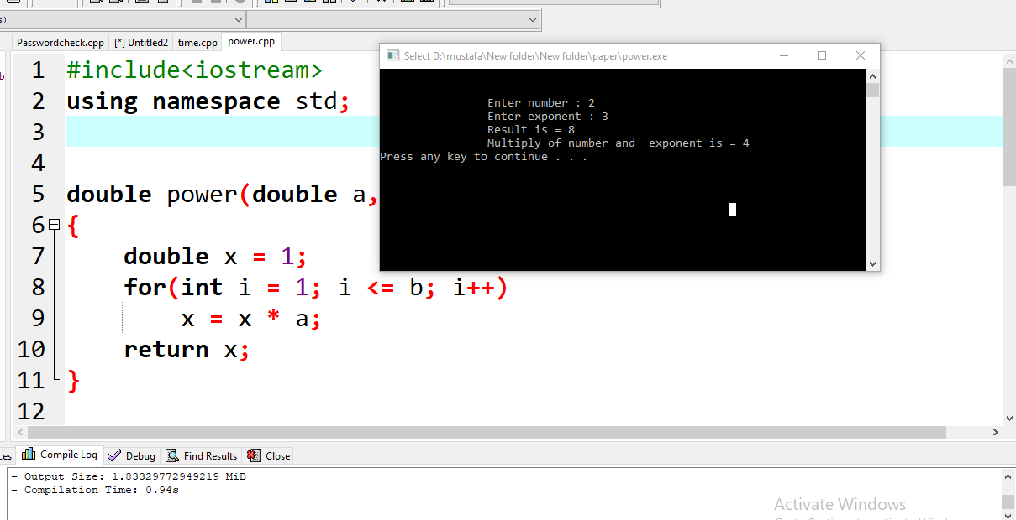

- Write a function called hms_to_secs() that takes three int values—for hours, minutes, and seconds—as arguments, and returns the equivalent time in seconds (type long). Create a program that exercises this function by repeatedly obtaining a time value in hours, minutes, and seconds from the user (format 12:59:59), calling the function, and displaying the value of seconds it returns.

Answer :

#include<iostream>
using namespace std;

int hms_sec(int h,int m, int s)
{
int seconds =0;
cout<<"\n\n";
cout << "\t\tEnter the hour = ";
cin >> h;
cout << "\t\tEnter the mints = ";
cin >> m;
cout << "\t\tEnter the second = ";
cin >> s;
seconds = (h*60*60)+(m*60)+s;
return seconds;
}

main()
{
int h,m,s;
int result =hms_sec(h,m,s);
cout<<"\n\n";
cout << "\t\tThe result in second = " << result<<endl<<endl;

system("pause");

return 0;
}

Output :
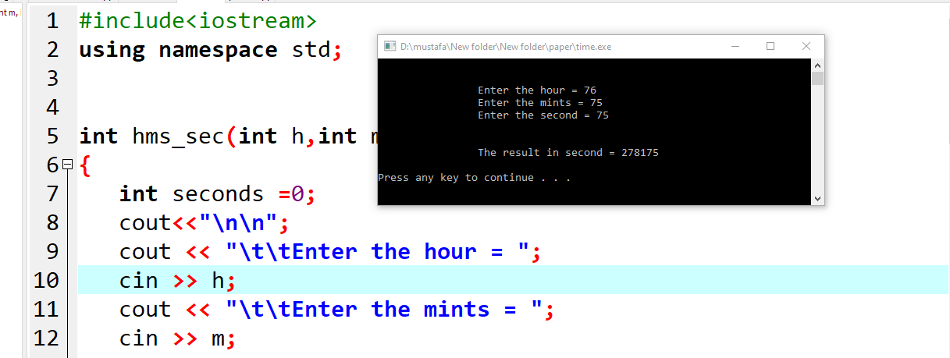

- Assume that you want to generate a table of multiples of any given number. Write a program that allows the user to enter the number and then generates the table, formatting it into 10 columns and 20 lines. Interaction with the program should look like this (only the first three lines are shown): Enter a number: 7

7 14 21 28 35 42 49 56 63 7
77 84 91 98 105 112 119 126 133 140
147 154 161 168 175 182 189 196 203 210

Answer:
#include <iostream>
#include <iomanip>
using namespace std;

int main()
{
unsigned long num;
cout << "\n\n\t\tEnter the number = ";
cin >> num;
cout<<"\n";
for (int i = 1; i <= 200; i++)
{
cout<<"\t"; cout<< setw(5) << i*num << " ";
if (i % 10 == 0)
cout << endl;
}

system("pause");
return 0;
}

Output:

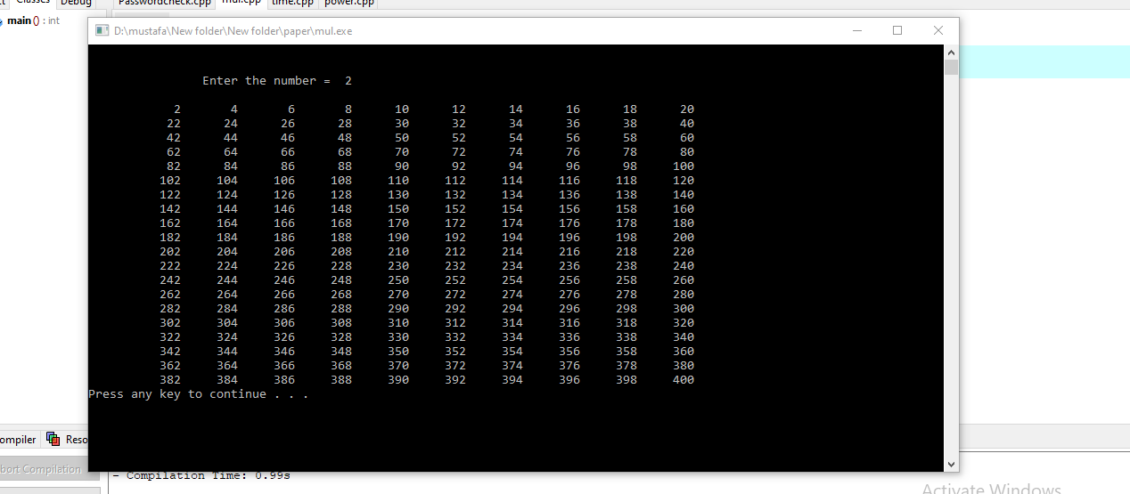
- Write a program that generates the following table:
1990 135
1991 7290
1992 11300
1993 16200
Use a single cout statement for all output.

Answer:
#include <iomanip>
using namespace std;

int main()
{
cout<<"\n\n\n";
cout<<"\t\t";cout << 1990 << setw(8) << 135 << endl
<<"\t\t" << 1991 << setw(8) << 7290 << endl
<<"\t\t" << 1992 << setw(8) << 11300 << endl
<<"\t\t" << 1993 << setw(8) << 16200 << endl;
return 0;
}

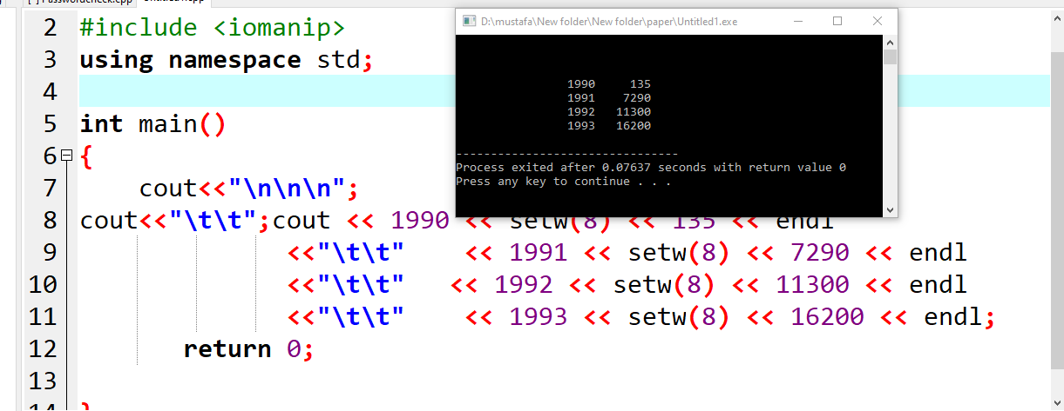

- Write a program that check a password.

#include<iostream>
#include<cstring>
using namespace std;

main()
{
char pas[22]="KhAn9012";
char pas1[22];
cout<<"Enter your password = ";
cin>>pas1;
if(strcmp(pas,pas1)==0)
{
cout<<"Your Password is correct"<<endl;
}
else
{
cout<<"Your password incorrect "<<endl;
}

system("pause");
}

Output:

